Hands-on exercises workshop 2 ML2

**Optional**: the notebooks use Keras/Tensorflow. Do the exercises on your own datasets using Pytorch, as Pytorch seems to be more popular than Keras/Tensorflow.

# Exercise 2.1: Deep Learning – shallow model

1. Open ‘Deep Learning.ipynb’ and run the ‘shallow model’ part.
2. Draw the neural network and draw the weights and biases that will be learned during training.
3. Why the shallow model does not work?

# Exercise 2.2: Deep Learning – deep model

1. Open ‘Deep Learning.ipynb’ and run the ‘deep model’ part.
2. Draw the neural network and draw the weights and biases that will be learned during training. How many layers does the neural network have?
3. Which optimizer is being used? Why an optimizer is used in neural networks?
4. How good is the classification, based on the accuracies obtained for the train and test set?
5. Does the model overfit?

# Exercise 2.3: Deep Learning – Iris dataset

The Iris dataset contains the length and width of the flowers of different types of irises.

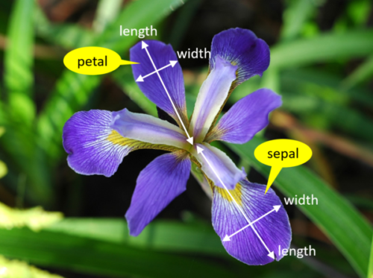

1. Open ‘Deep Learning.ipynb’ and run the ‘The iris dataset’ part.
2. Draw the neural network and draw the weights and biases that will be learned during training. How many layers does the neural network have?
3. Why does the model use softmax as activation function?
4. Investigate the influence of the hyperparameter learning rate on the learning performance.
5. Does the model overfit?
6. The classification report shows precision, recall and f1-score. Explain these values. Draw conclusions about the reliability of the classification, based on the values in the classification report.
7. What can you learn from the confusion report?

# Exercise 2.4: Your own classification model

1. Find an own dataset on the internet suitable to perform classification.
2. Define a classification research question. Keep it simple.
3. Go through the data science life cycle: data exploration & visualization, create a model that uses a neural network, train & evaluate.
4. Draw conclusions.